# Refactoring to Multiclient architect

## Analysis on existing code

The application will start the main form with a navigator. The navigator holds all controllers (use cases level component with views and presenters defined for each steps). Currently, the main form holds a composite default navigator. We need to refactor the main form to allow us to inject the navigator instead of instantiate in it. The idea is simple! However, the dependencies could be heavy or no, we hope.

### From the startup application

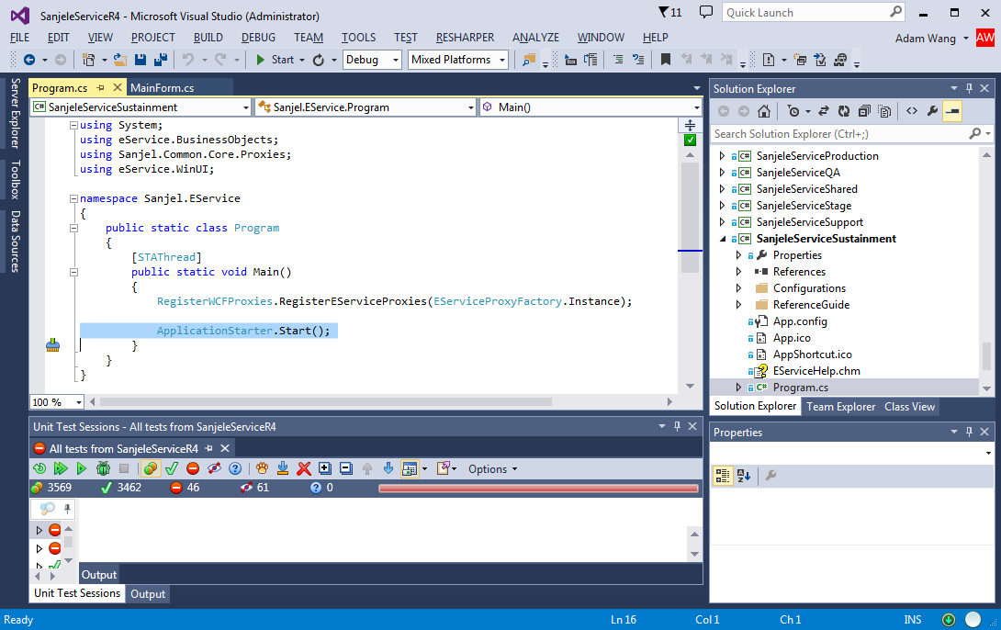

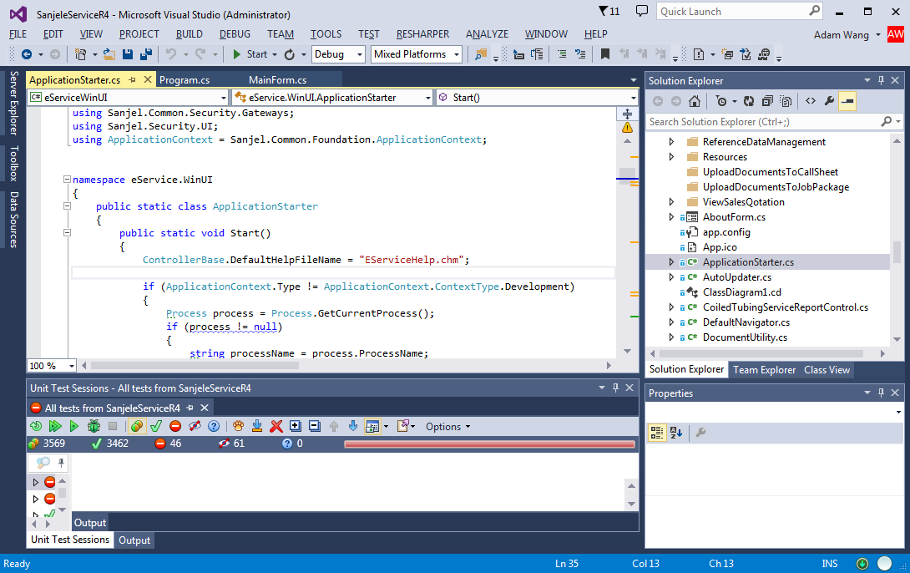

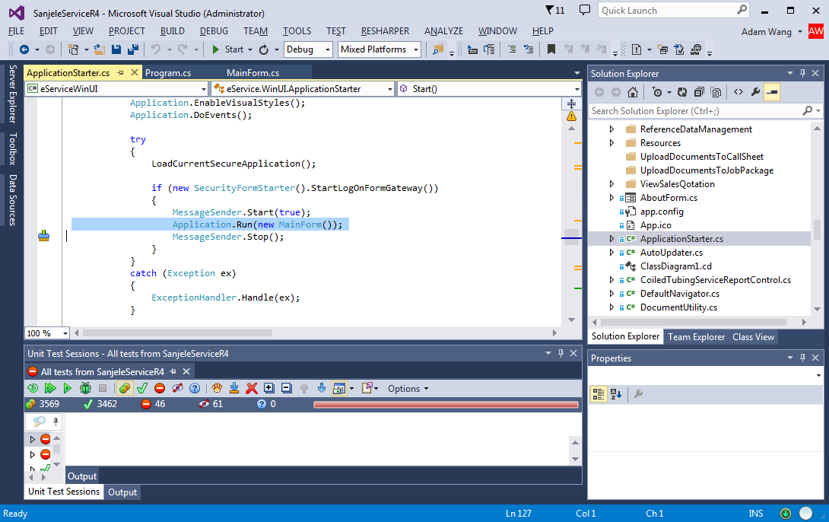

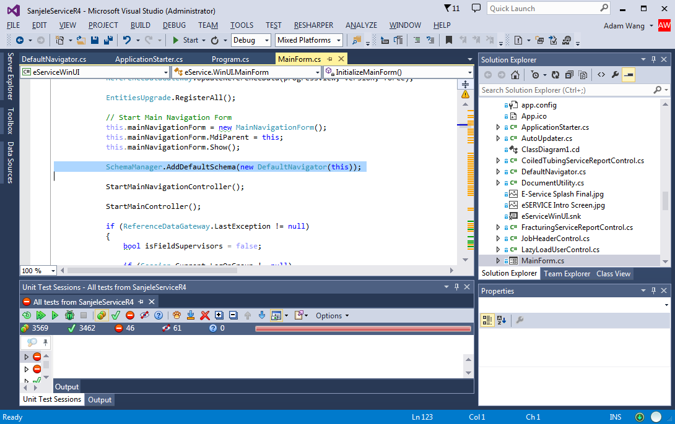

So lucky, only one reference to DefaultNavigator! However, we notice DefaultNavigaor has a Form parameter passed in.

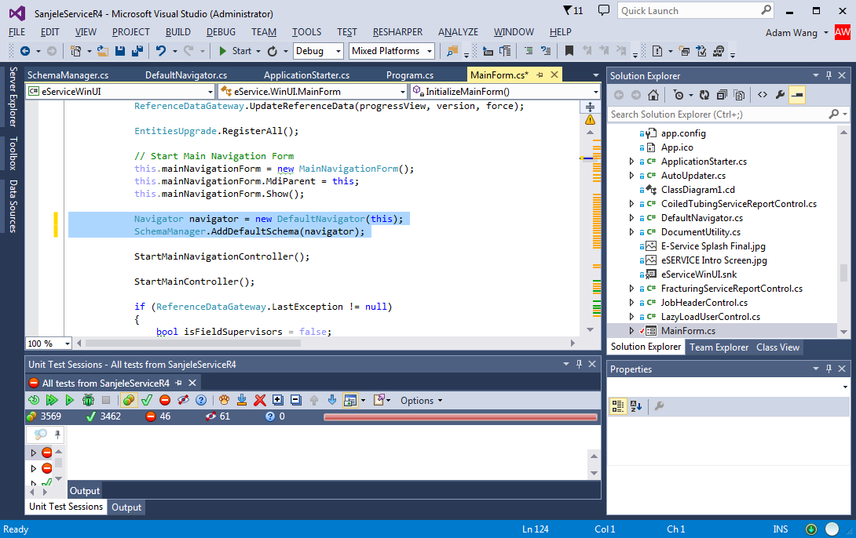

Extra a variable of Navigator(Not DefaultNavigator because we want a more general type here!) Run to test it still works!

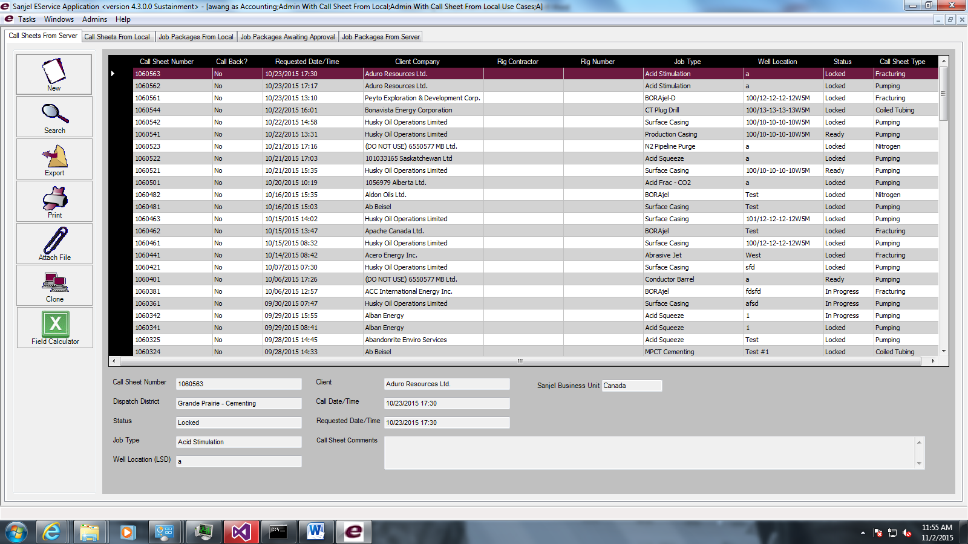

Yahoo! It is so simple this step. However, DefaultNavigator has a Form parameter. We need to have this parameter from constructor to a setter method, so that we can instantiate a Navigator without a Form.

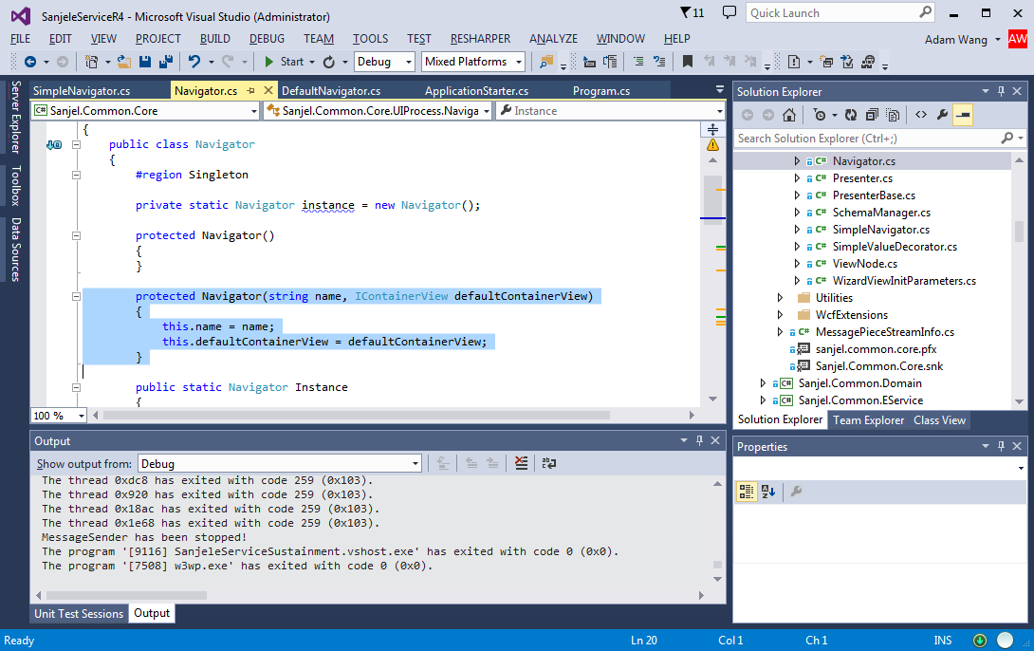

After checking the code in Navigator, we know that navigator has a name and containerview as parameters. The original constructor has some issue. We need to change a little bit.

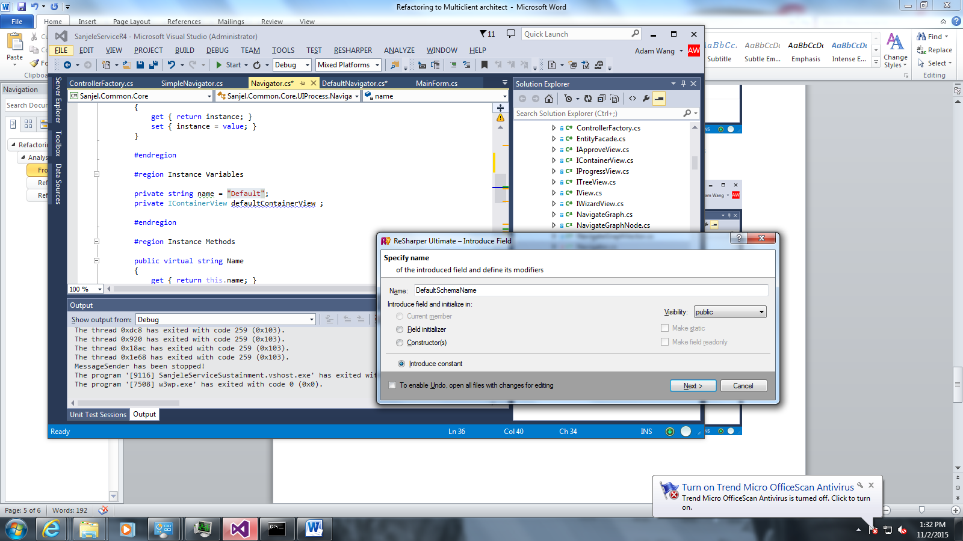

Extract “Default” as a constant string DefaultSchemaName.

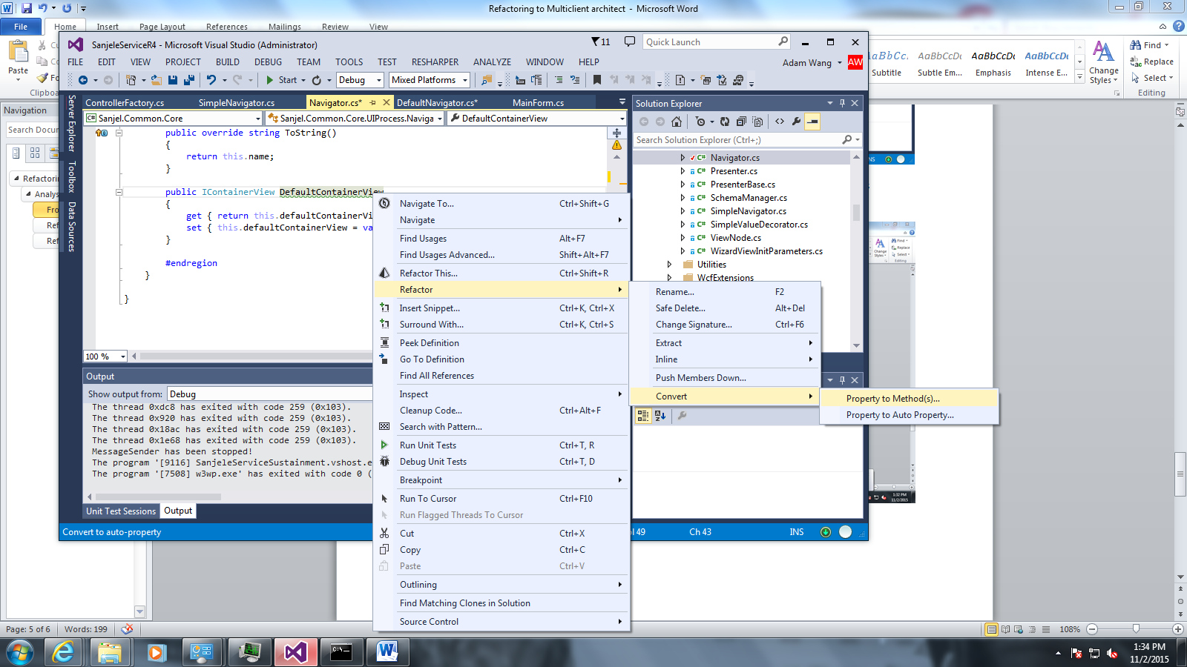

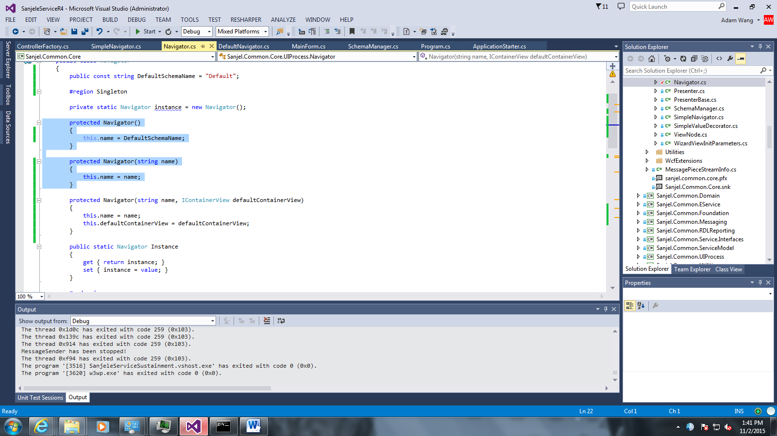

Modify Navigator constructors. There are two constructors without defaultContainerView paramters.

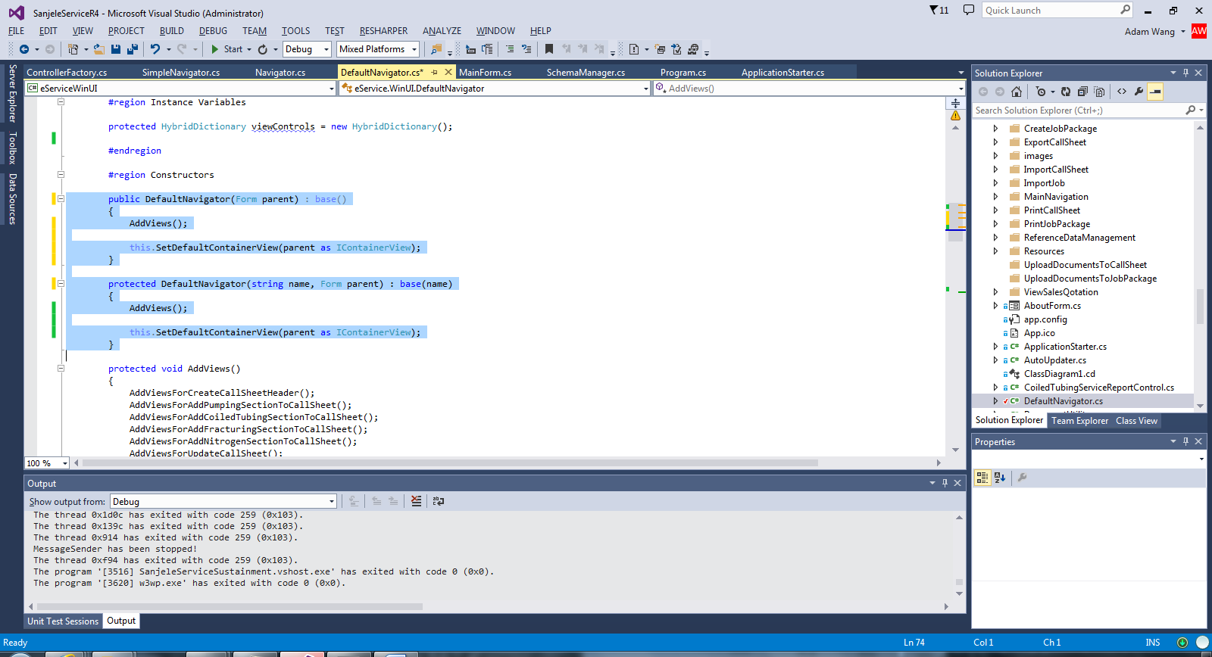

We delete the parentView property and call the simpler constructor without container View parameter.

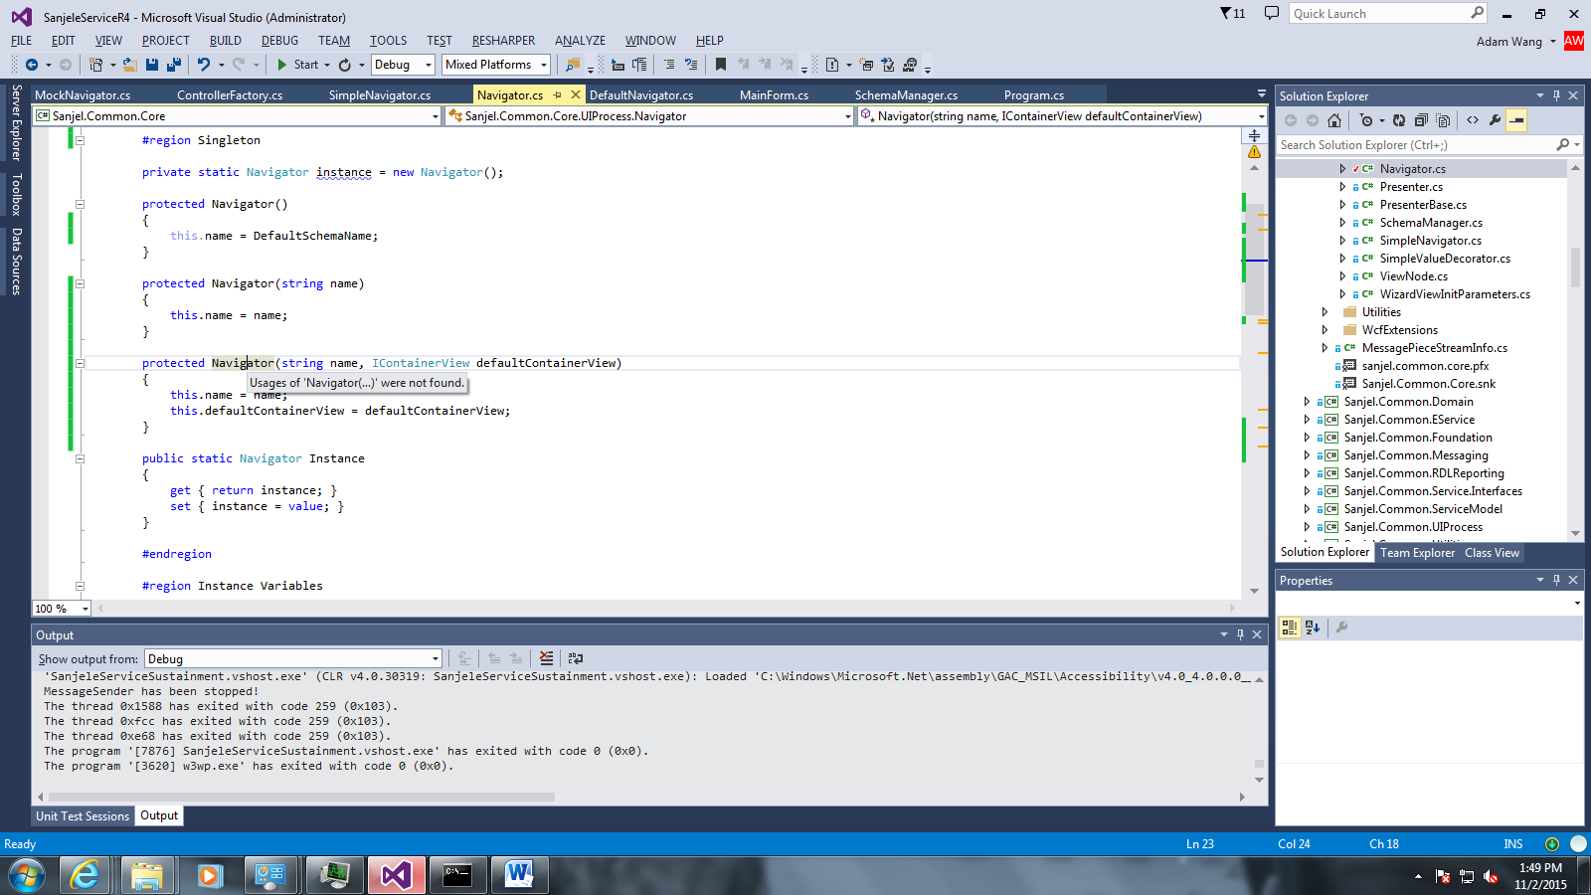

We found there are no references to Navigator constructor with defaultContainerView. To prevent someone use it in a wrong way. We will delete this constructor.

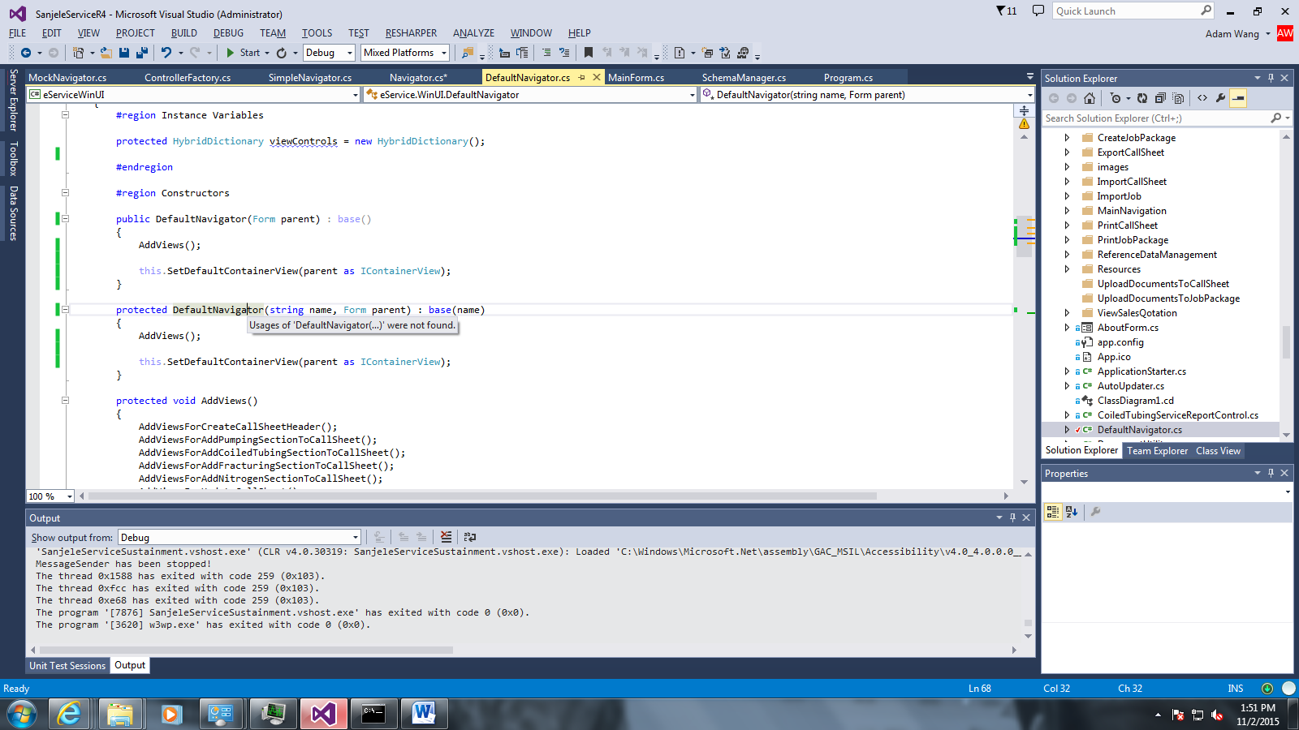

We will also delete the constructor of DefaultNavigator.

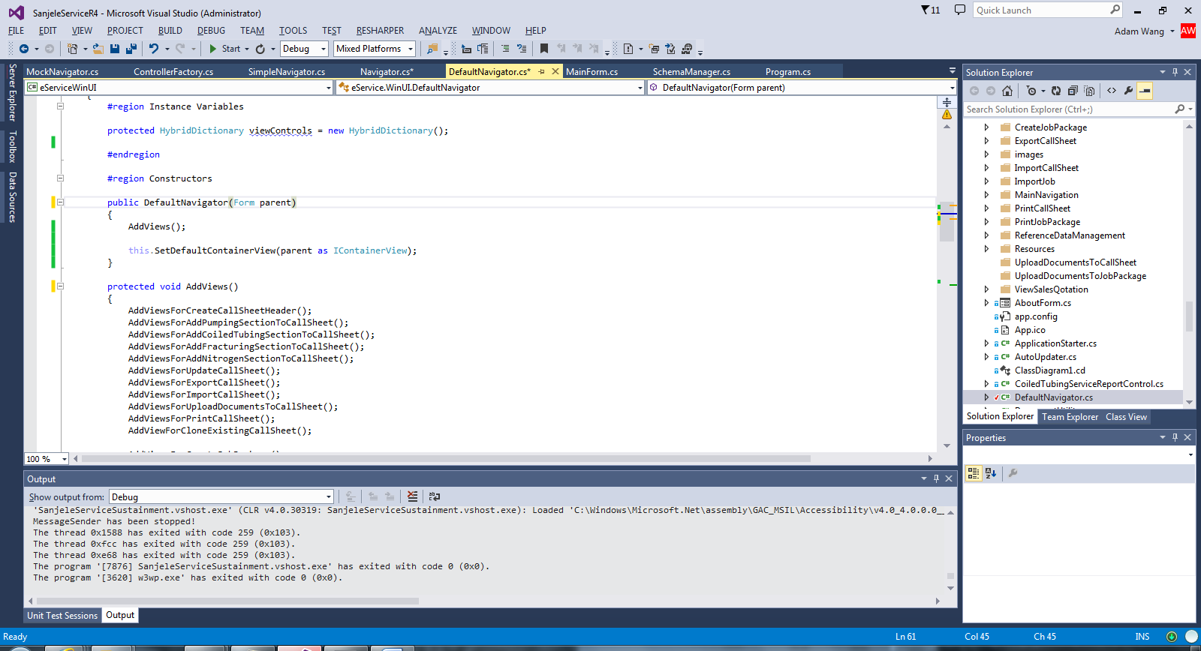

The result will be like this. Try to run it! We need to run all the tests to make sure we did not break anything and check in. Refactor in small step!!! The test will run for a long time. Take some time to do further analysis! Do not waste your time!!!

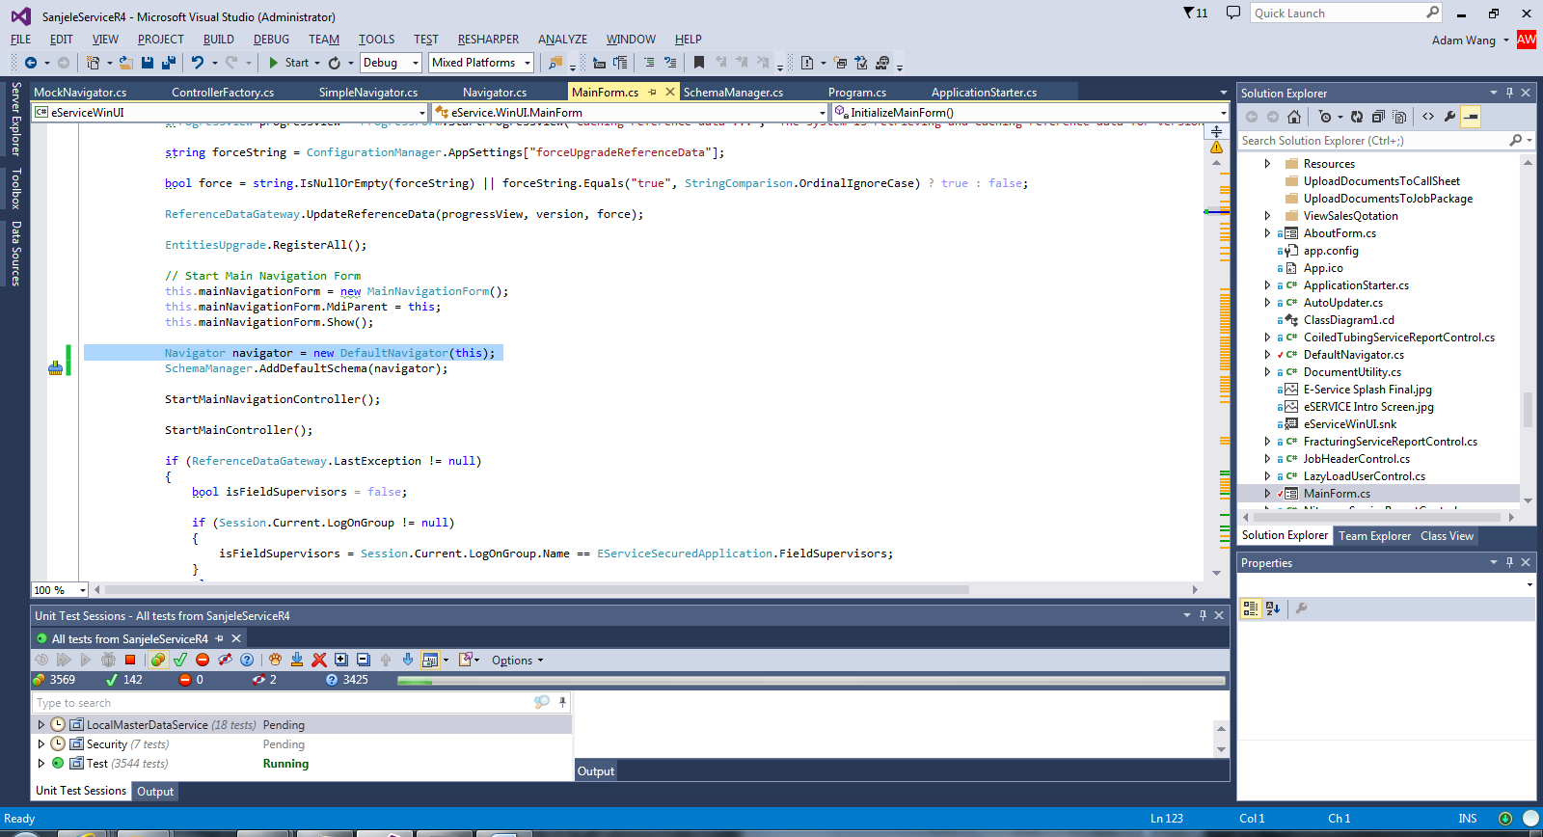

In the constructor of DefaultNavigator(). You have the following two line of code: AddViews() and SetDefaultContainterView(). In the MainForm, we do not know if we move the instantiate before the calling method. The AddViews() should appear in current location or the place instantiation. The reason could be .NetFramework might need the instantiation of the views and controls in the MainForm because the MainForm is the parent window. It could be risky to move the AddViews code before MainForm.

### Build initial Sanjel.Common.UIFramework project

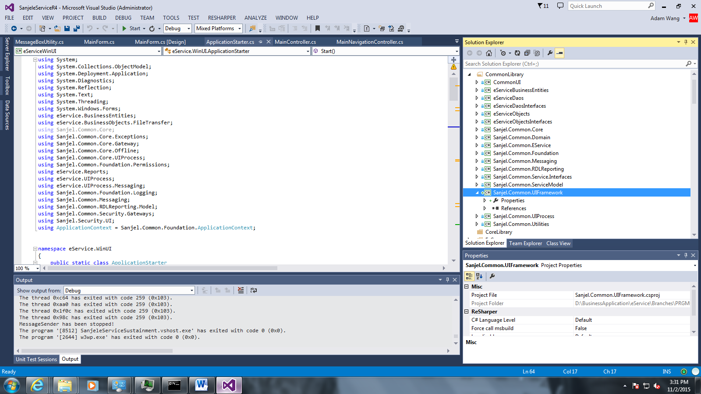

Create the project and add its reference to EServiceWinUI

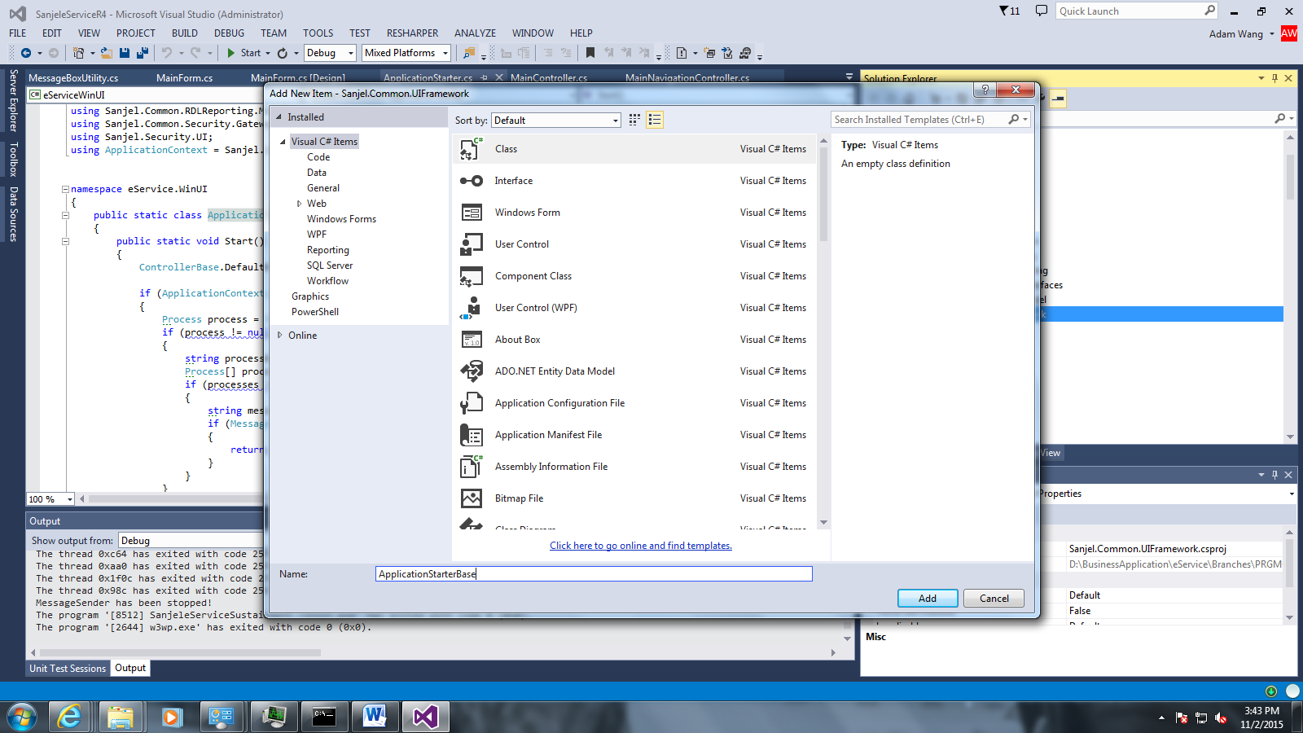

Add a ApplicationStarterBase as the base class of ApplicationStarter

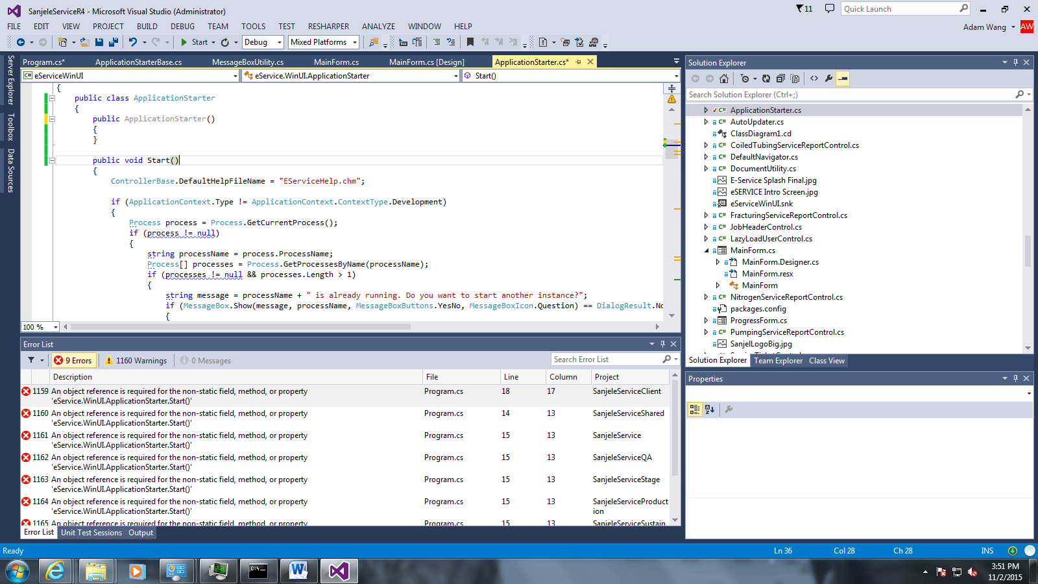

We need to hold some configuration in ApplicationStarter. So change static class ApplicationStarter to regular class and static Start() to instance method and modify all its references by change the compiling errors! Run it and test!

### 

Change all its reference to an new ApplicationStarter

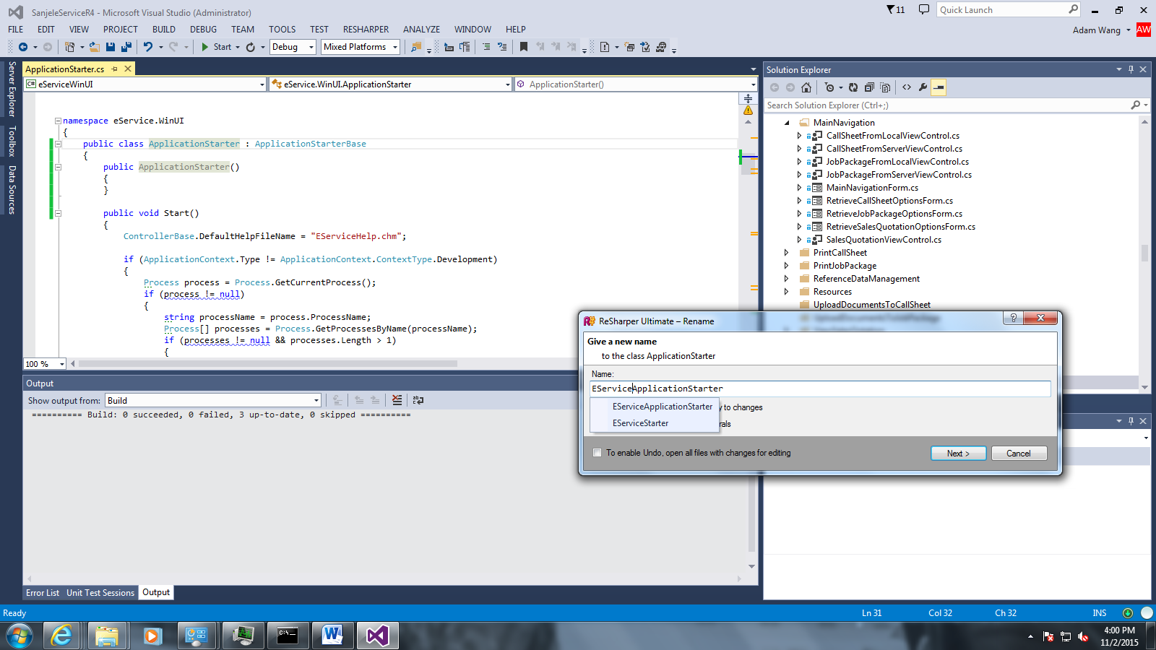

Add ApplicationStarterBase as the base class. Then I think EServiceApplicationStarter may be better and ApplicationStarterBase to ApplicationStarter

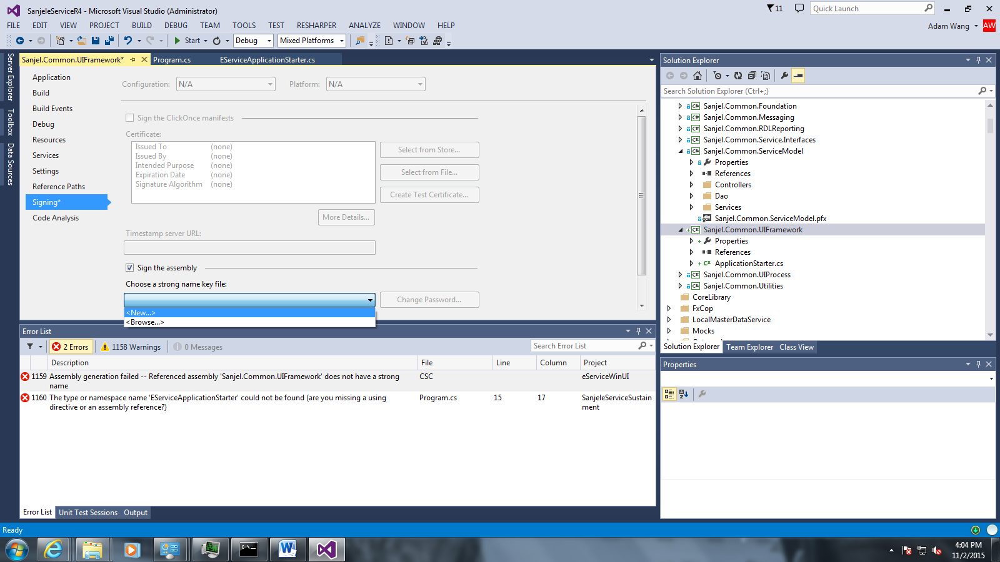

To support strong new, need to sign the assembly

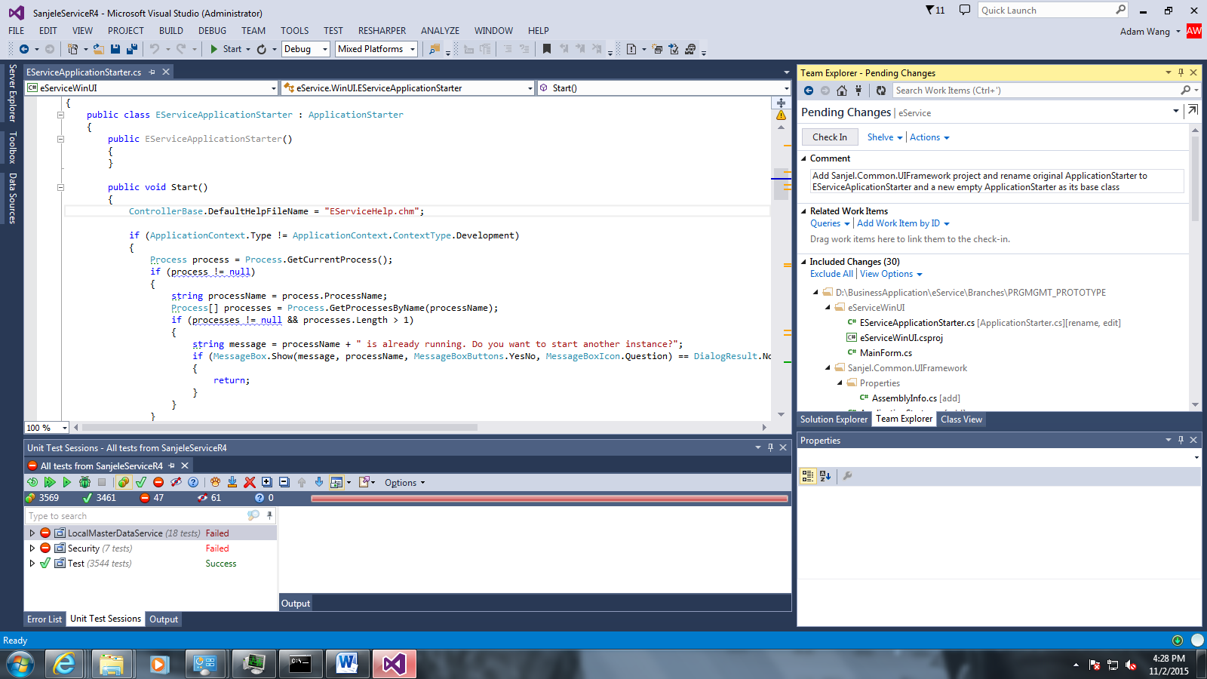

Run test and check in!

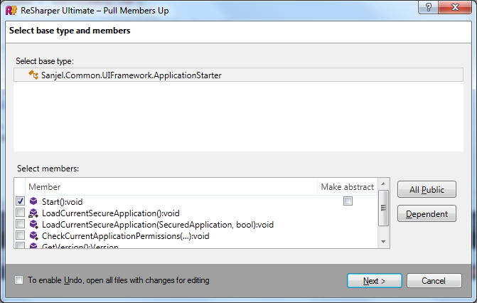

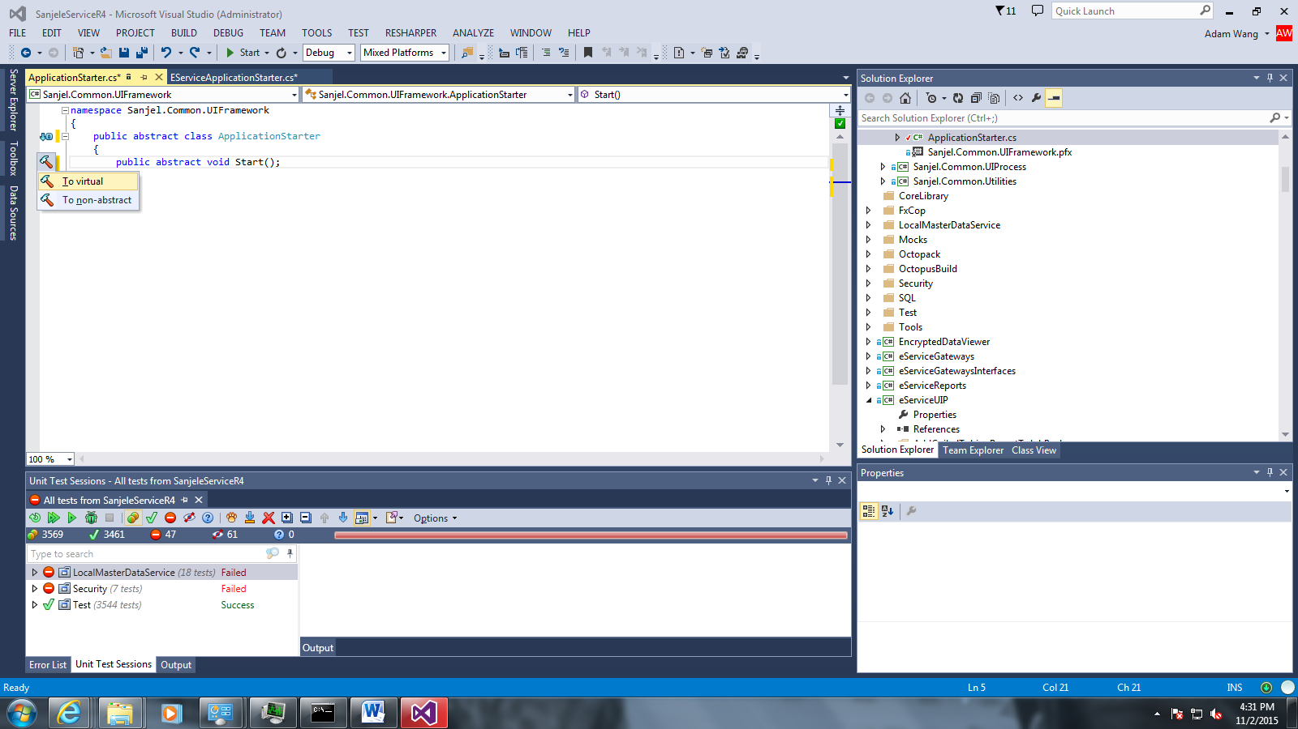

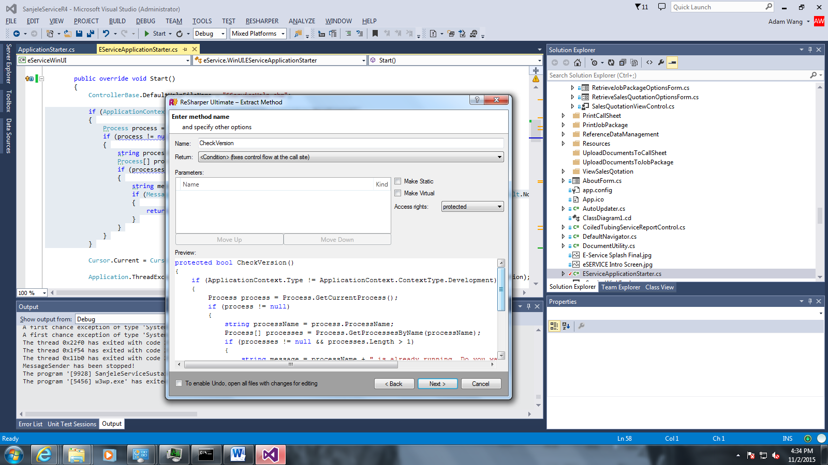

Extract method CheckVersion

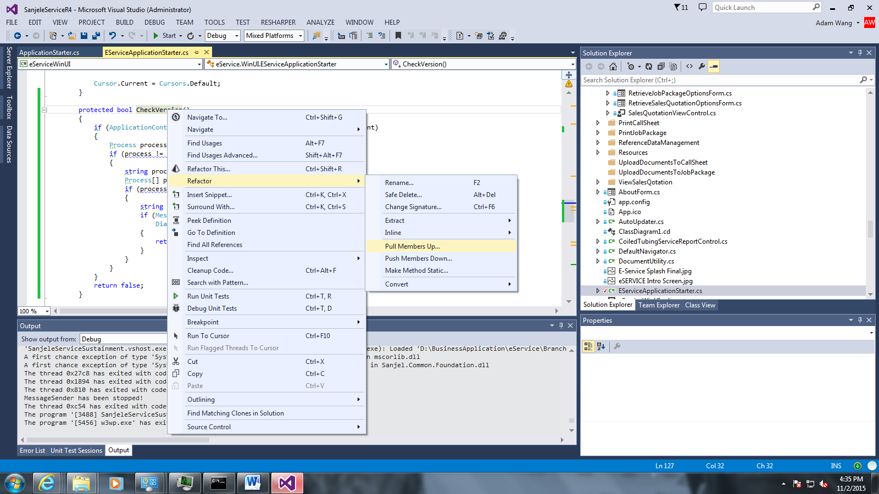

Pull method CheckVersion to ApplicationStarter

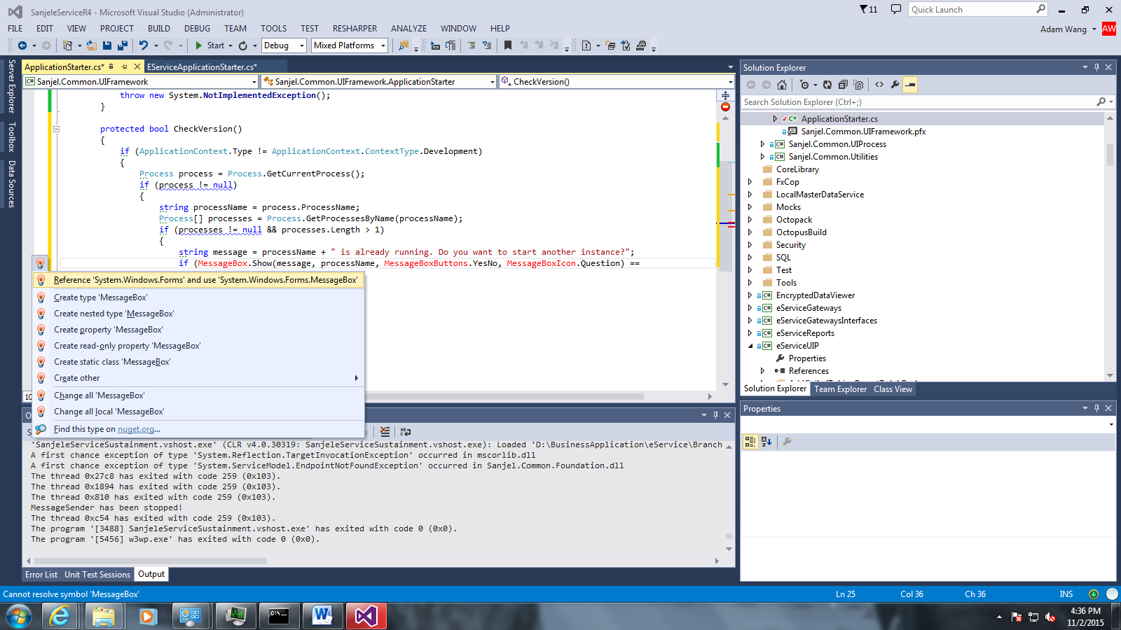

ReSharper will help us add reference!

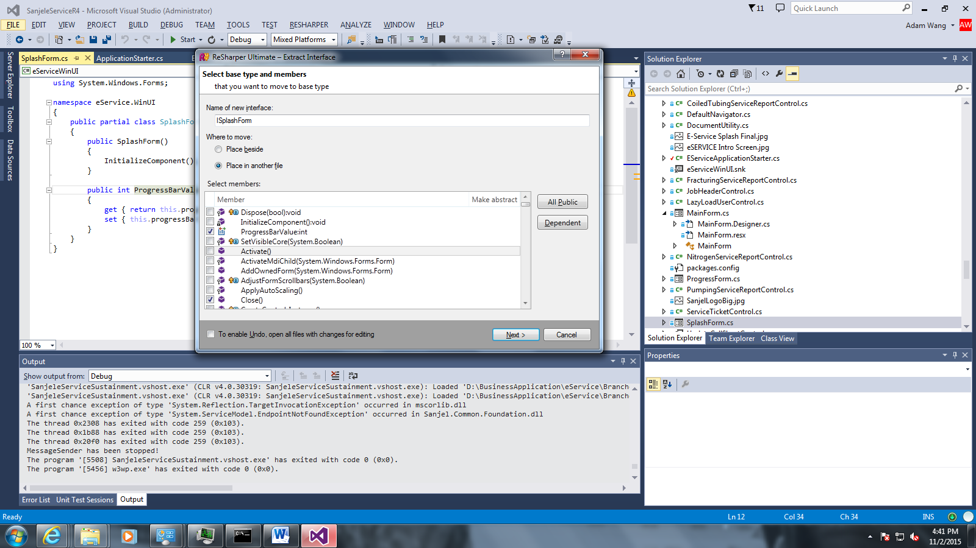

Extract interface ISplashForm

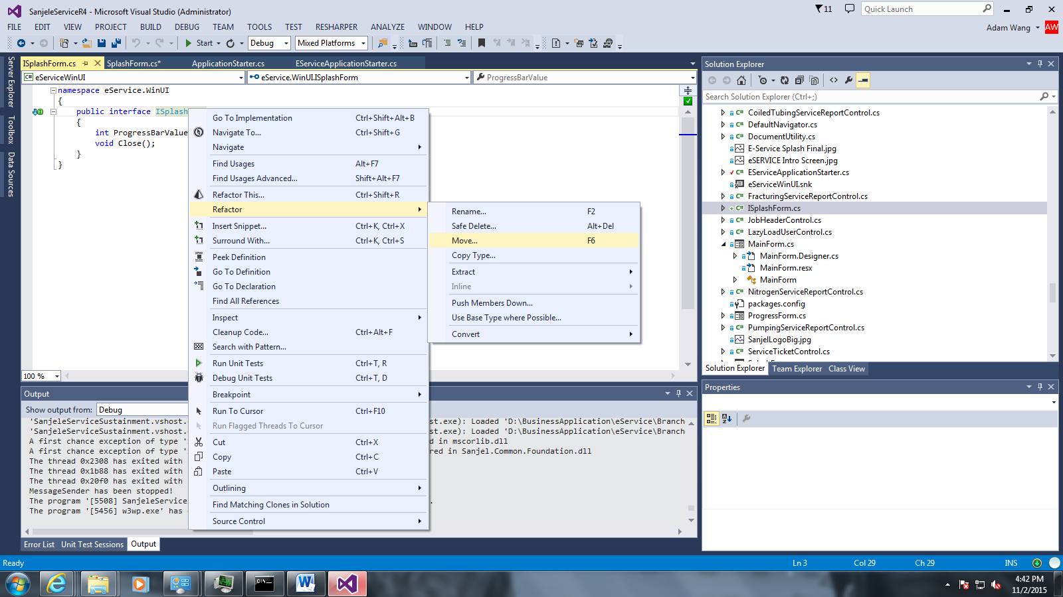

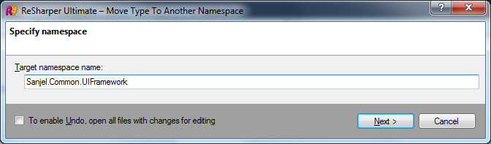

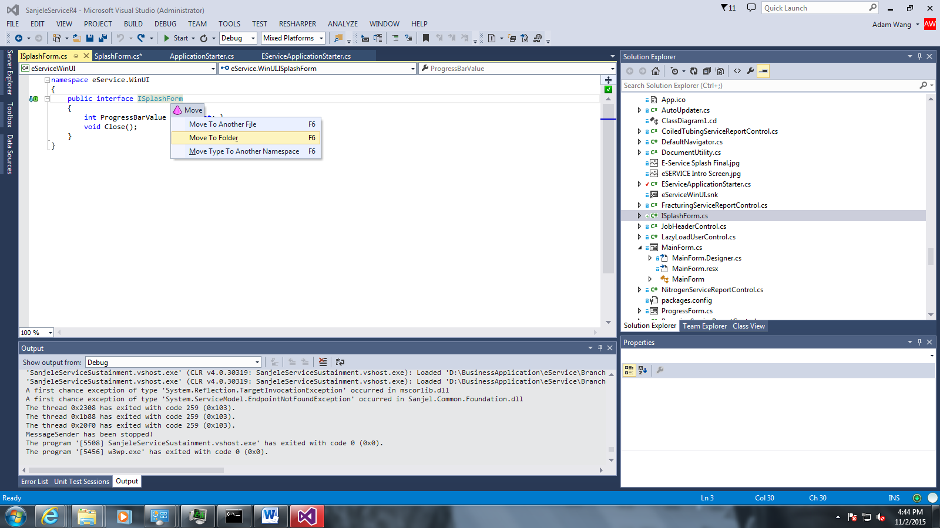

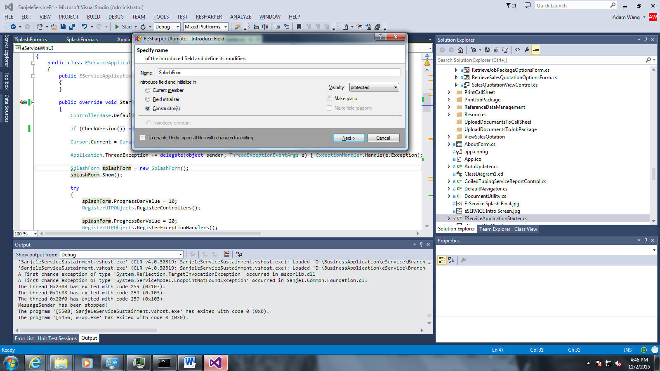

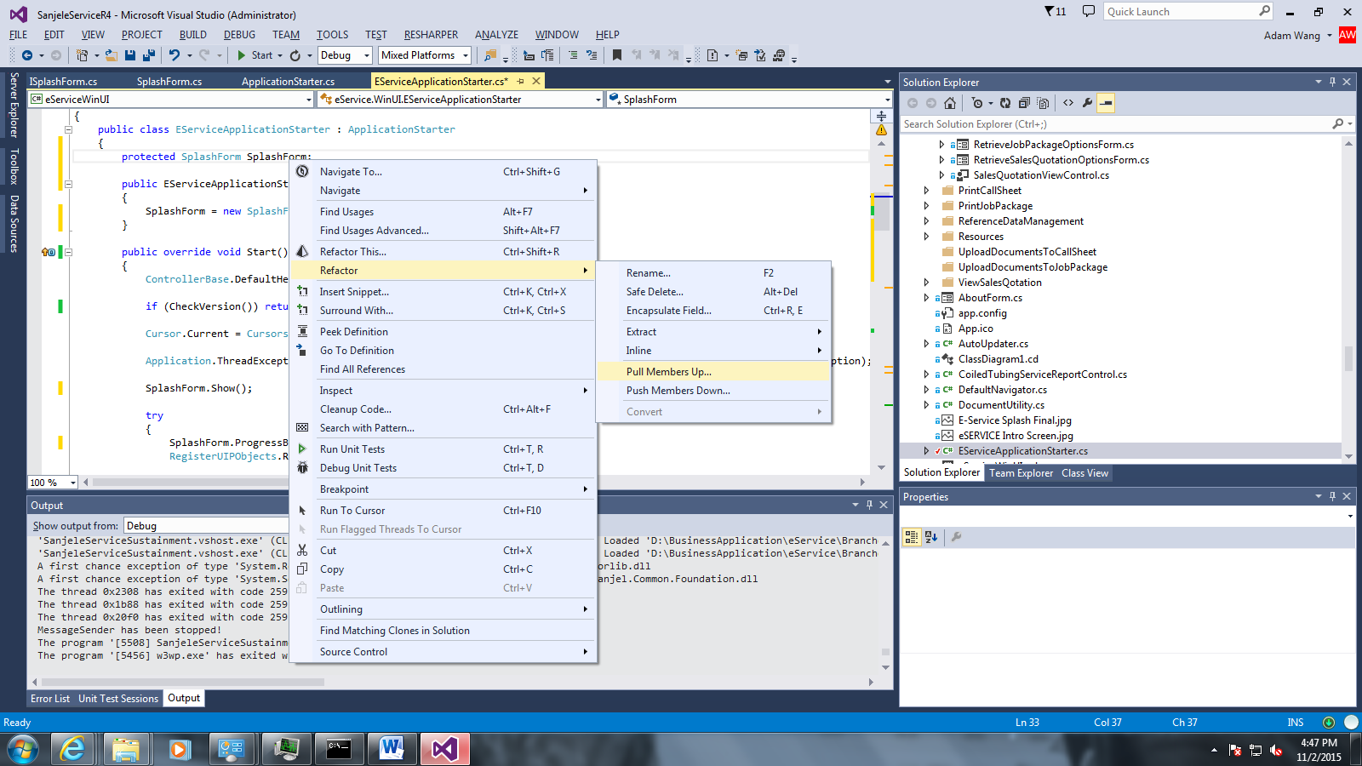

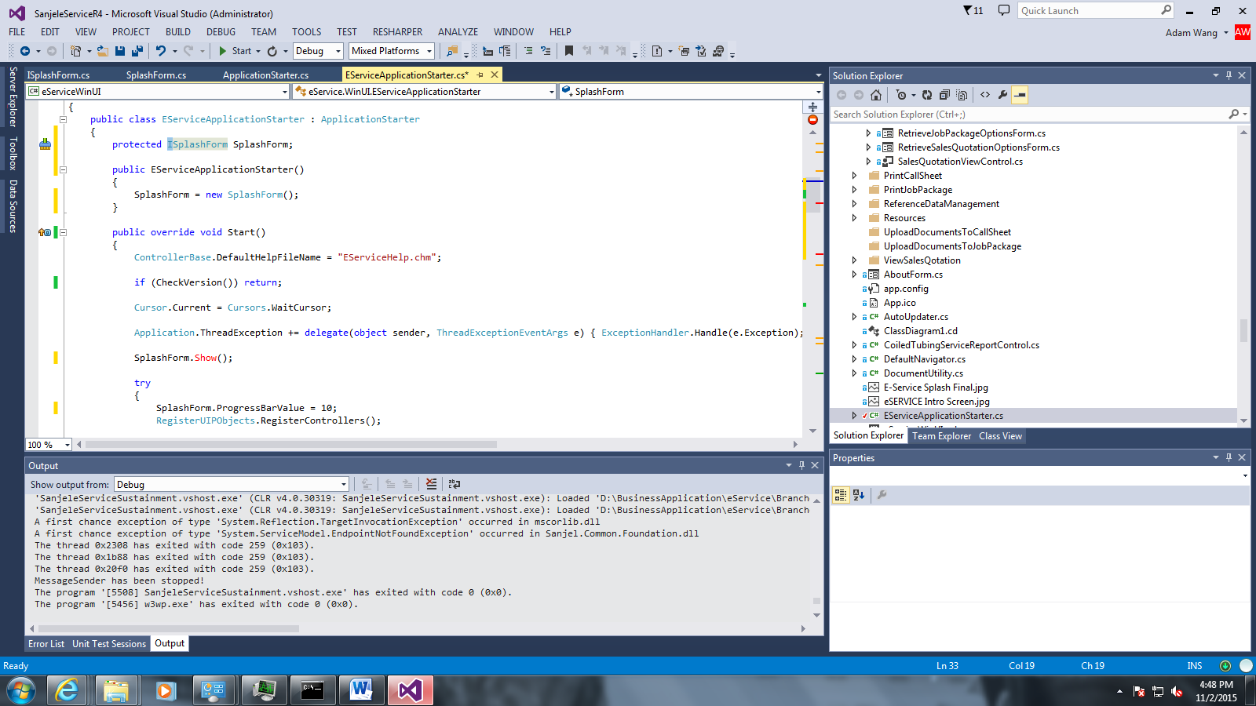

Change the field type from SplashForm to ISplashForm

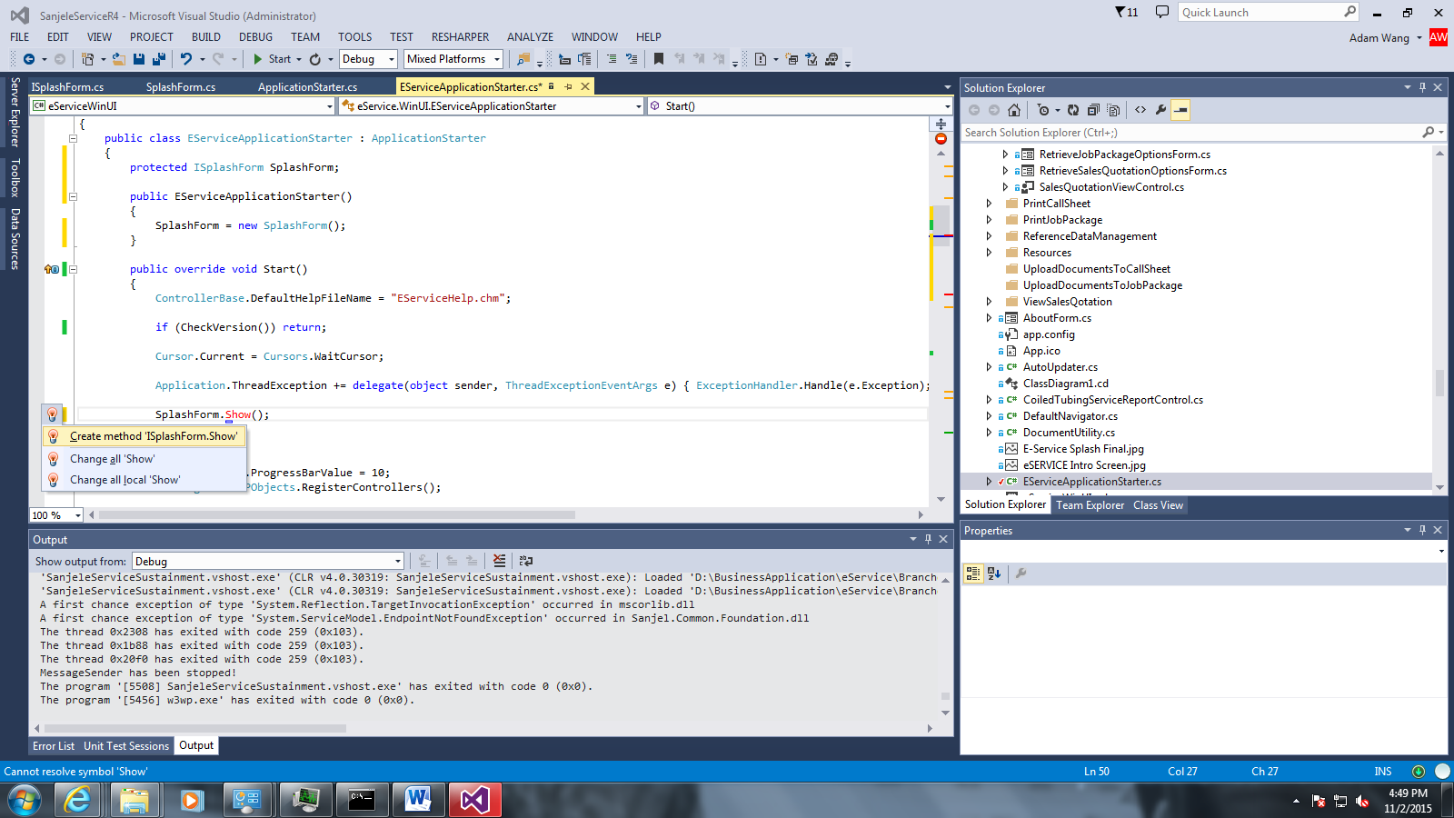

ReSharper will help us to create the rest method in the ISplashForm

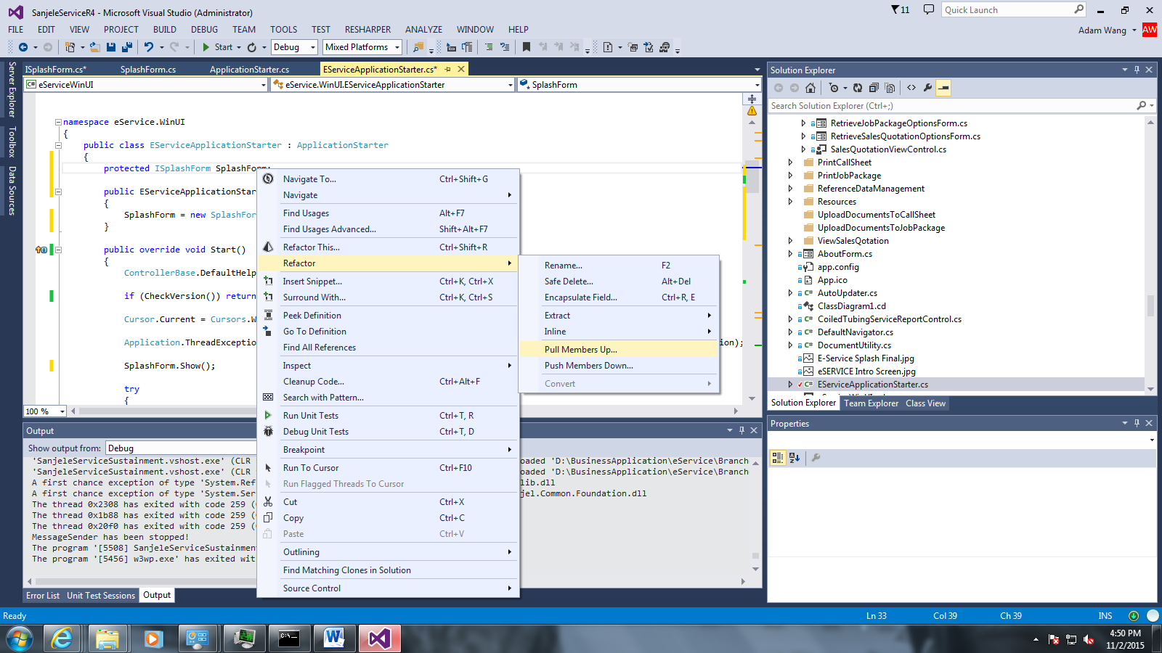

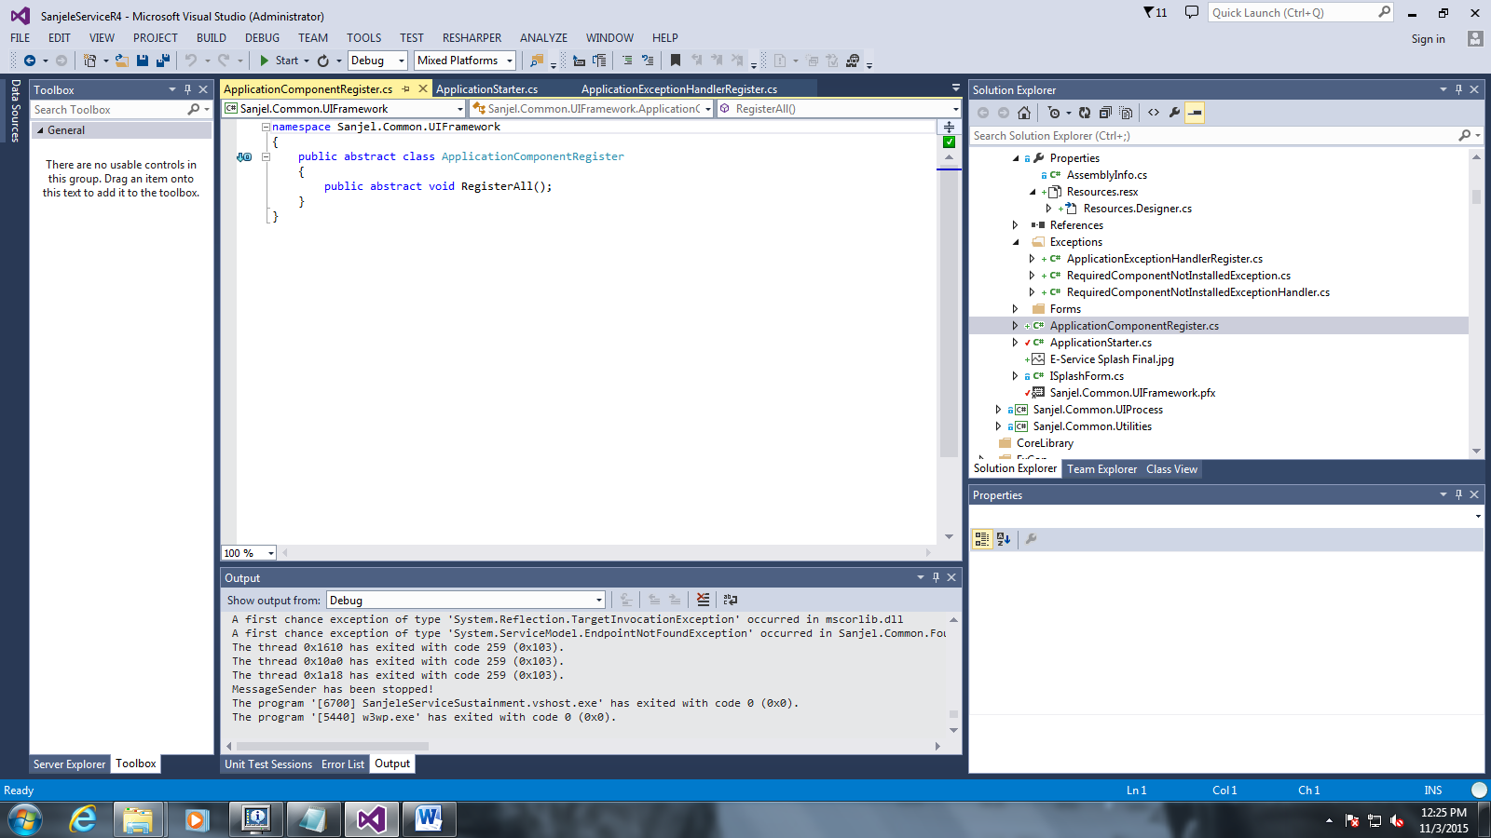

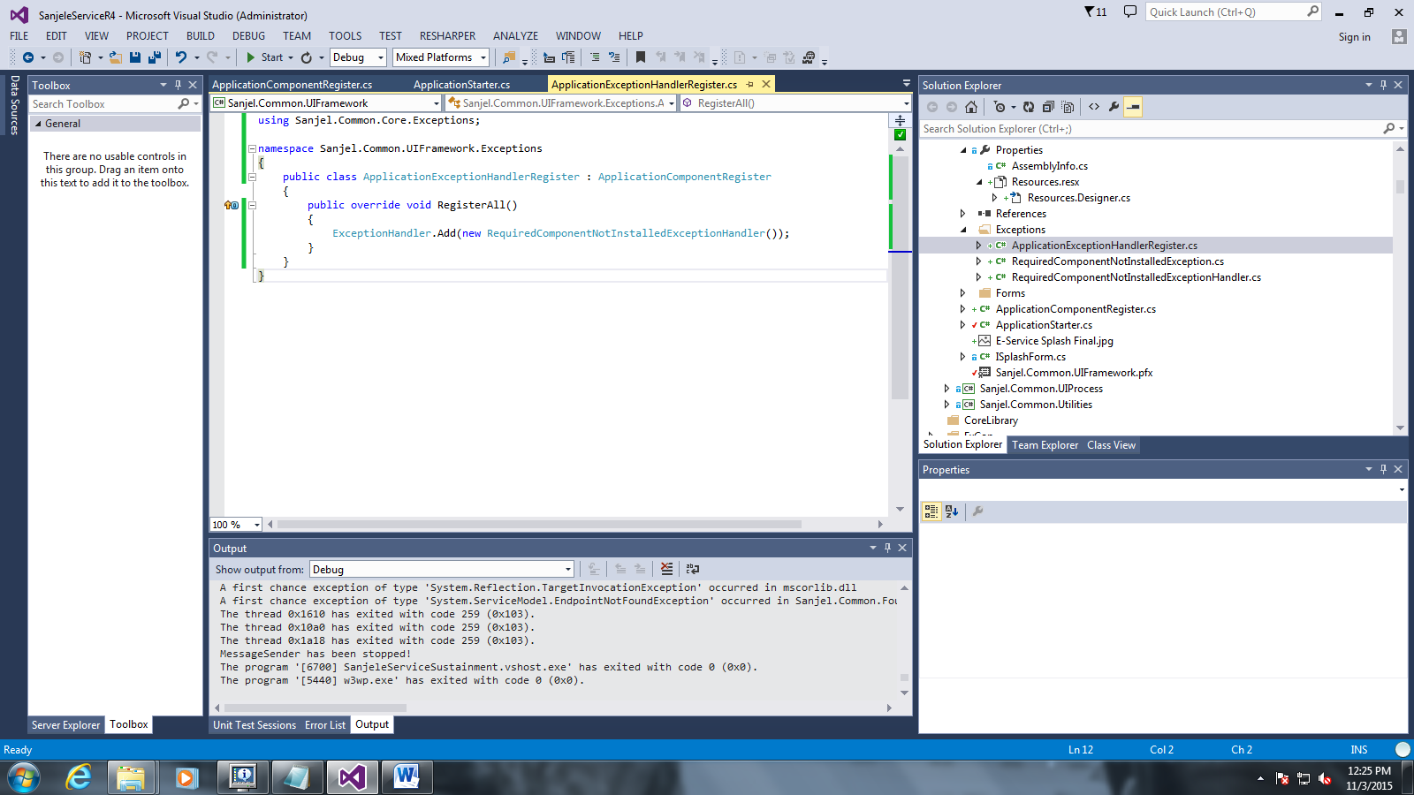

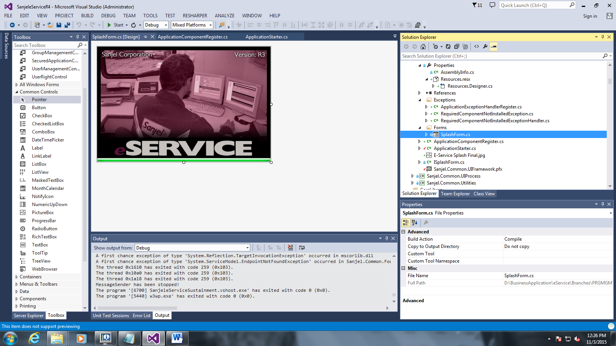

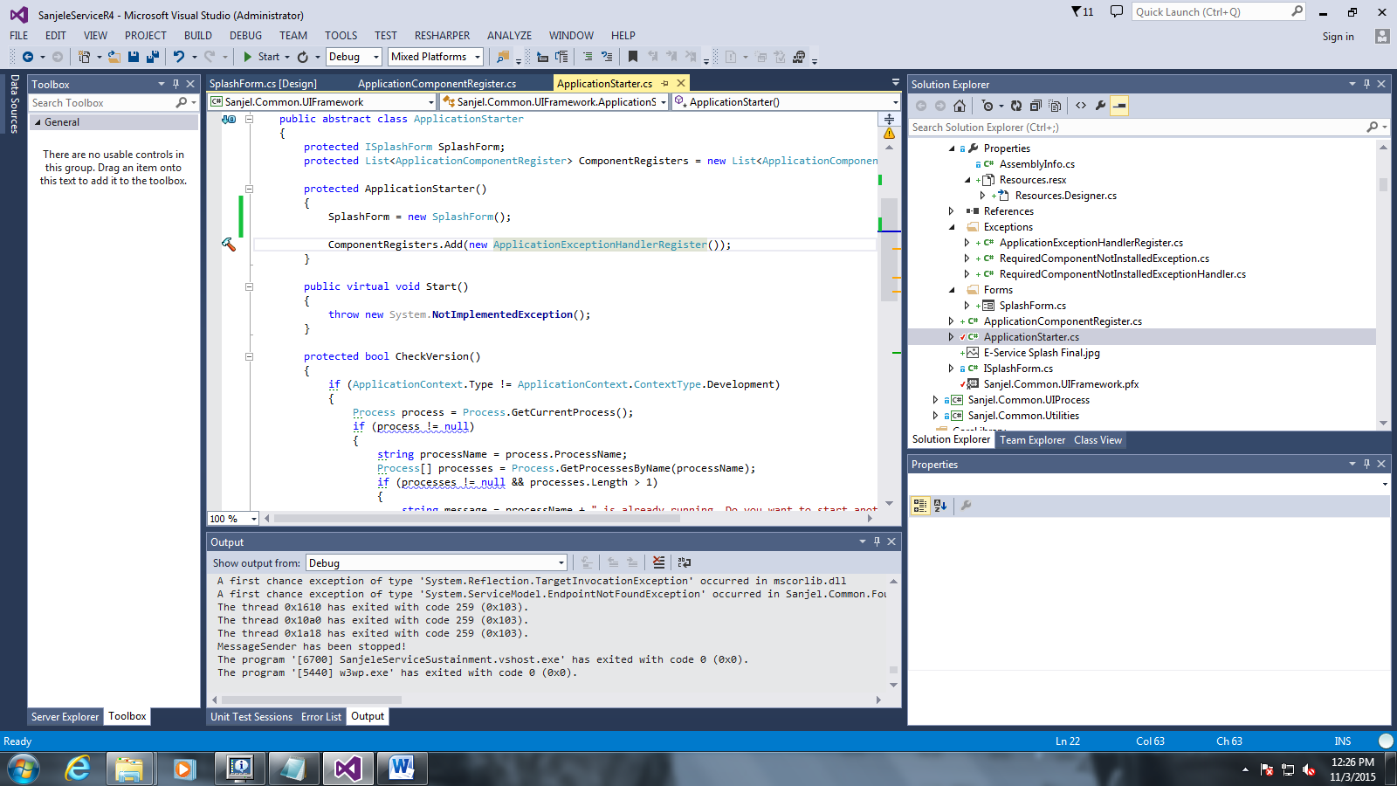

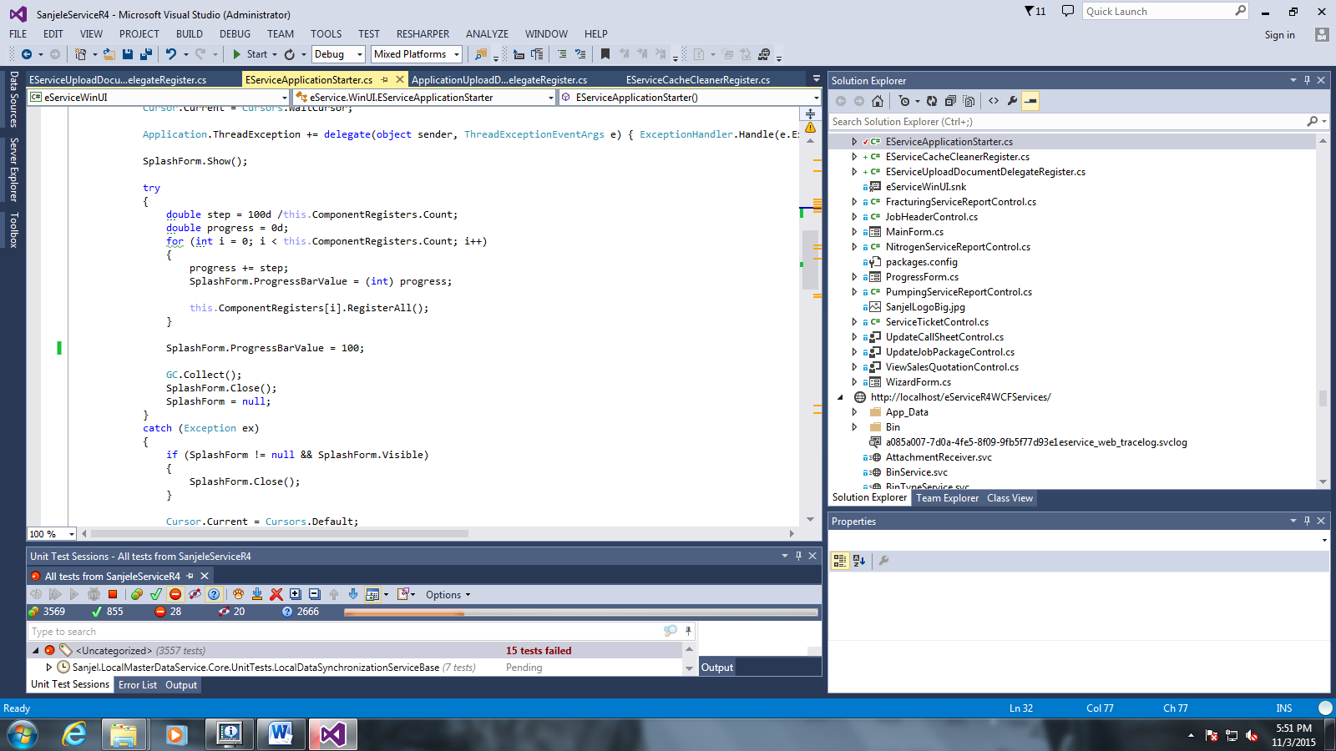

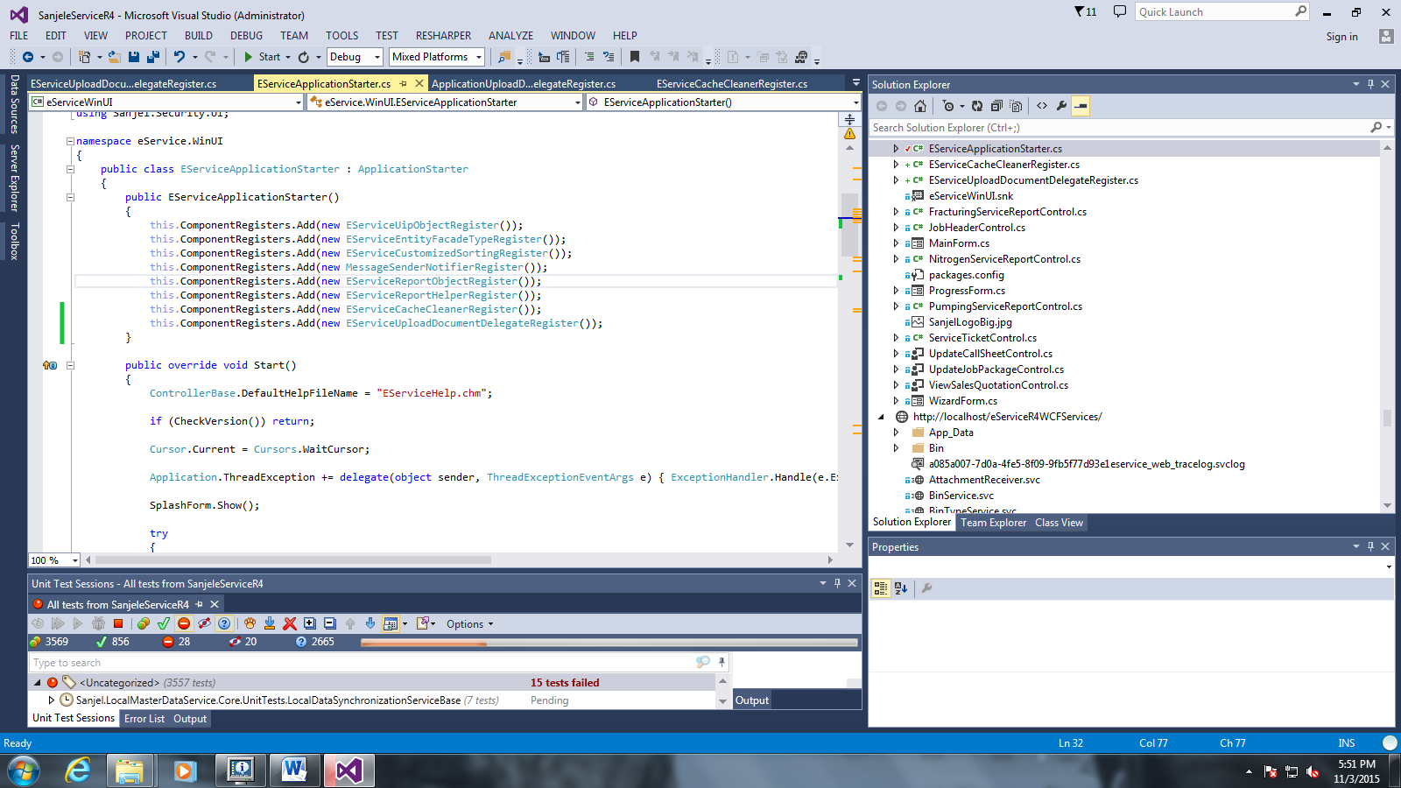

### Refactoring MainForm to make Navigator property injectable

### Refactor the

